Exercise 5: Styling React Components using CSS Modules and Inline Styles
Aim
To style React components using CSS Modules and apply conditional styling using inline styles.

Objectives
- Understand the need for styling React components.
- Work with CSS Modules and inline styles.
- Style React components using CSS.
- Apply styles using the className property.
- Apply conditional styles using the style property.

Software Requirements
- Node.js
- NPM
- Visual Studio Code
- ReactJS

Procedure
- Download and extract the React application.
- Open Command Prompt and navigate to the project folder.
- Install dependencies using: npm install
- Open the project in Visual Studio Code.
- Create a CSS Module file named CohortDetails.module.css.
- Define the required CSS styles in the module file.
- Import the CSS module into the CohortDetails component.
- Apply the CSS class using the className attribute.
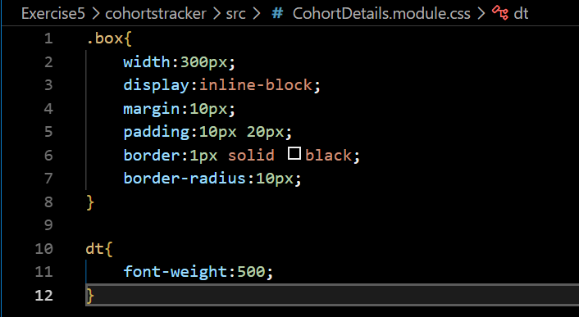
- Use inline styling to display:
  - Green color for ongoing cohorts.
  - Blue color for all other cohorts.
- Save the files and execute the application.
- Open the browser and verify the output.

Output
The application displays cohort details inside styled boxes. The cohort heading is displayed:
- Green for ongoing cohorts.
- Blue for scheduled/completed cohorts.
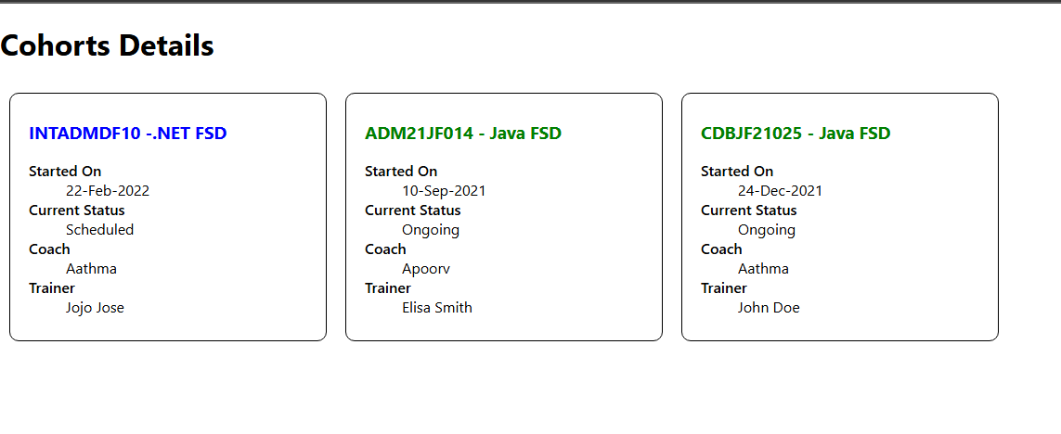

Result
The React application was successfully styled using CSS Modules and inline styles. The cohort details were displayed inside styled containers, and conditional formatting was applied to the cohort headings based on their status. Thus, styling React components using CSS Modules and inline styles was implemented successfully.

